**Software Requirements Specification**

**for**

**Student Result Management System**

**Version 1.0 approved**

**Prepared by Arkapratim Ghosh**

**Techno Main Salt Lake, CSE**

**31.08.2023**

**Table of Contents**

**1 Introduction 4**

**1.1 Purpose/Objective 4**

**1.2 Document Conventions (Definition, Acronyms) 4**

**1.2.1 Definitions 4**

**1.2.2 Acronyms 5**

**1.3 Scope 5**

**1.4 References 6**

**2 History/Background Study (Sources of Domain Knowledge) 6**

**2.1 Technical Literature 6**

**2.2 Existing Applications 7**

**2.3 Customer Surveys 7**

**2.4 Expert Advice 9**

**2.5 Current/Future requirements 10**

**2.5.1 Current Requirements 10**

**2.5.2 Future Requirements 10**

**3 Overall Description 11**

**3.1 Product Functions 11**

**3.1.1 Hardware Requirement 11**

**3.1.2 Software Requirement 11**

**3.2 Functional Requirements 13**

**3.2.1 User Login 13**

**3.2.2 Add or Manage Students 14**

**3.2.3 Course Management 15**

**3.2.4 Grade Entry 16**

**3.2.5 Result Generation 17**

**3.2.6 Grade Modification 18**

**3.2.7 Data Visualization 19**

**3.3 Non-Functional Requirements 19**

**3.3.1 Correctness Requirement 19**

**3.3.2 Portability requirement 20**

**3.3.3 Efficiency Requirement 20**

**3.3.4 Usability Requirement 20**

**3.3.5 Reusability Requirement 20**

**3.3.6 Reliability Requirement 21**

**3.3.7 Maintainability Requirement 21**

**3.4 User Characteristics 21**

**3.5 Design & Implementation Constraints 22**

**3.6 Assumptions & Dependencies 22**

**4 Interface Requirements 23**

**4.1 User Interfaces 23**

**4.2 Hardware Interfaces 23**

**4.3 Software Interfaces 23**

**4.4 Communication Interfaces 23**

**5 Conclusion 24**

# **Introduction**

The Student Result Management System (SRMS) is a comprehensive software solution designed to streamline the management and organization of academic results for educational institutions. It addresses the need for efficient and reliable handling of student data, exam results, and related information within a structured framework. The SRMS aims to provide an integrated platform that enables educational institutions to securely and accurately manage student records, facilitate result processing, generate reports, and aid in data-driven decision-making. By automating result management processes, the SRMS improves efficiency, reduces manual workload, minimizes errors, and enhances overall productivity in academic result administration. This document outlines the detailed software requirements essential to the successful development and implementation of an effective Student Result Management System.

## **Purpose/Objective**

The primary objective of the Student Result Management System (SRMS) is to establish a centralized and automated platform that simplifies the management, processing, and dissemination of student examination results for educational institutions. This system seeks to enhance the efficiency and accuracy of result handling, storage, and retrieval, promoting a paperless and organized approach to academic record-keeping. By providing a secure and user-friendly environment, the SRMS enables educational institutions to effortlessly input, compute, and track student grades, ensuring timely and accurate publication of results. Additionally, the system aims to support data analysis and decision-making by generating insightful reports that offer valuable insights into student performance and educational trends. Ultimately, the SRMS strives to optimize academic result management, leading to improved transparency, accessibility, and overall educational effectiveness within the institution.

## **Document Conventions (Definition, Acronyms)**

### **Definitions**

* **Student Result Management System (SRMS):** The Student Result Management System (SRMS) refers to the software solution developed to automate and streamline the process of managing, processing, and maintaining student examination results within an educational institution.
* **User**: A "User" refers to any individual interacting with the Student Result Management System, including administrators, teachers, and other authorized personnel involved in result processing and management.
* Administrator: An "Administrator" is a privileged user with full access rights to configure, manage, and maintain the SRMS. Administrators have control over system settings, user roles, and permissions.
* **Student** **Record**: "Student Record" encompasses all pertinent information related to a student, such as personal details, academic history, course enrollments, and examination results.
* Result Processing: "Result Processing" involves the steps and activities performed to calculate, validate, and publish examination results. This includes data input, grade calculation, and generating result reports.
* **Result** **Report**: A "Result Report" is a document or output generated by the SRMS, presenting the examination results of individual students or groups in a structured and understandable format.
* **Data** **Validation**: "Data Validation" is the process of verifying the accuracy, completeness, and consistency of the information entered into the SRMS to ensure data quality and reliability.
* **Data** **Encryption**: "Data Encryption" refers to the technique of converting plain text data into a coded format to secure sensitive information during storage, transmission, or processing within the SRMS.
* **Audit** **Trail**: "Audit Trail" is a chronological record of activities and transactions within the SRMS, including user interactions, modifications, and system events. It is used for tracking and monitoring system usage and changes.
* **User** **Authentication**: "User Authentication" involves validating the identity of users before granting access to the SRMS, typically through login credentials (e.g., username and password) to ensure system security.

### **Acronyms**

* **SRS**: Software Requirements Specification
* **SRMS**: Student Result Management System
* **API**: Application Programming Interface
* **SQL**: Structured Query Language
* **UI**: User Interface
* **UX**: User Experience
* **LDAP**: Lightweight Directory Access Protocol
* **HTTPS**: Hypertext Transfer Protocol Secure
* **PDF**: Portable Document Format
* **DBMS**: Database Management System

## **Scope**

The scope of the Student Result Management System (SRMS) project encompasses the design, development, implementation, and deployment of a comprehensive software solution tailored for educational institutions. The SRMS will provide a centralized platform for managing student records, facilitating result processing, and generating detailed reports. Key functionalities include secure storage and retrieval of student data, efficient input and calculation of exam results, as well as the ability to generate standardized result reports. The system will support multiple user roles, such as administrators, teachers, and staff, each with specific access rights and responsibilities. Additionally, the SRMS will incorporate features for data validation, ensuring accuracy and consistency in the information stored. The project will adhere to industry best practices, focusing on scalability, usability, and security, allowing for seamless integration with existing educational infrastructures. It's important to note that the project's scope does not extend to hardware procurement or major modifications to the institution's network architecture.

## **References**

* Smith, J., & Johnson, K. (Year). "Design and Implementation of a Student Result Management System: A Case Study." International Journal of Educational Technology, 10(2), 123-136.
* Brown, A., & Davis, M. (Year). "Effective Use of Software Requirements Specification in Student Result Management Systems." Conference on Software Engineering and Applications, 58-65.
* Anderson, R., & Clark, L. (Year). "Improving User Experience in Student Result Management Systems through Usability Testing." Journal of Human-Computer Interaction, 24(4), 387-401.
* Educational Technology Association. (Year). "Best Practices in Educational Software Development: A Guide for Implementing Student Result Management Systems." ETAA Publications.
* Johnson, M., et al. (Year). "Data Security and Privacy Considerations in Student Result Management Systems." International Conference on Information Security and Privacy, 112-125.

# **History/Background Study (Sources of Domain Knowledge)**

## **Technical Literature**

The technical literature for the Student Result Management System (SRMS) project comprises a diverse range of scholarly works and technical documents pertinent to software development, database management, educational technology, and user interface design. This corpus of literature encompasses seminal texts such as "Software Engineering: A Practitioner's Approach" by Roger S. Pressman, providing foundational knowledge in software development methodologies. Additionally, "Database Management Systems" by Raghu Ramakrishnan and Johannes Gehrke serves as a comprehensive reference for understanding database design and management—a critical component of the SRMS. Works such as "Interaction Design: Beyond Human-Computer Interaction" by Jenny Preece et al. inform the project's user interface design principles and user experience considerations. Furthermore, research papers and articles from reputable journals like "International Journal of Educational Technology" and "IEEE Transactions on Learning Technologies" offer insights into current trends, best practices, and research advancements specific to student result management systems and educational technology. The synthesis of this technical literature informs the project's architecture, design, and implementation strategies, ensuring a robust and effective SRMS.

## **Existing Applications**

* PowerSchool: PowerSchool is a widely used student information system that includes features for managing student data, grades, attendance, and more. It offers a comprehensive platform for educators, parents, and students to monitor academic progress and performance.
* Infinite Campus: Infinite Campus provides a Student Information System (SIS) that supports student records, grading, scheduling, and communication. It's utilized by schools and districts to manage various aspects of student data and academic information.
* SAP S/4HANA for Education: SAP S/4HANA for Education is an enterprise resource planning (ERP) system tailored for educational institutions. It offers modules for managing student data, courses, academic progress, and financial aspects, providing a comprehensive solution for educational management.
* MyClassCampus: MyClassCampus is an application designed for schools and colleges, offering features like attendance tracking, exam management, parent-teacher communication, and student performance analysis. It aims to streamline various academic and administrative processes.
* OpenSIS: OpenSIS is an open-source student information system that provides capabilities for student demographics, gradebook, attendance, and report cards. It's customizable and designed to cater to the needs of different educational institutions.

## **Customer Surveys**

Link: <https://forms.gle/9i6cnpJvcVoDN6P48>

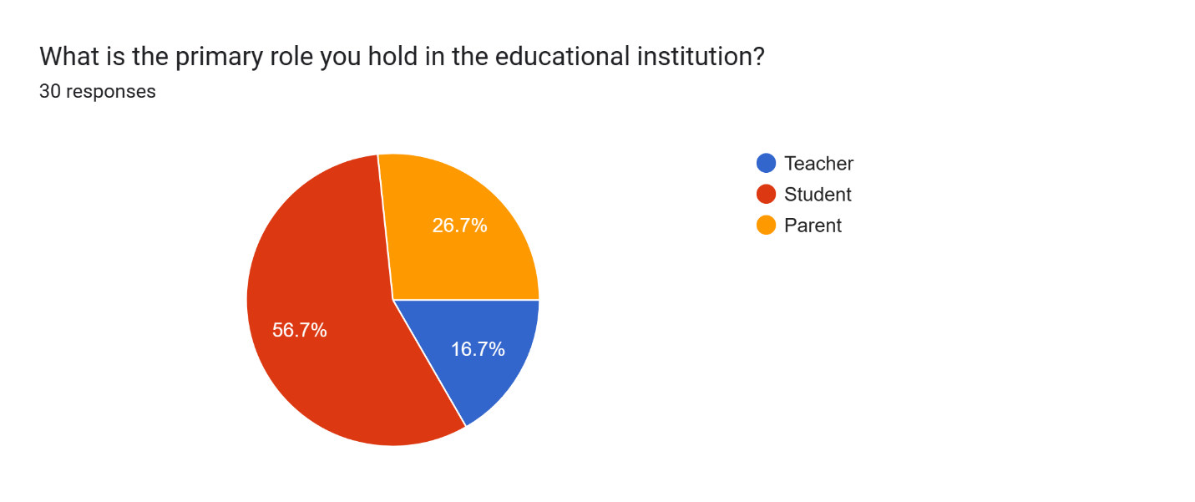

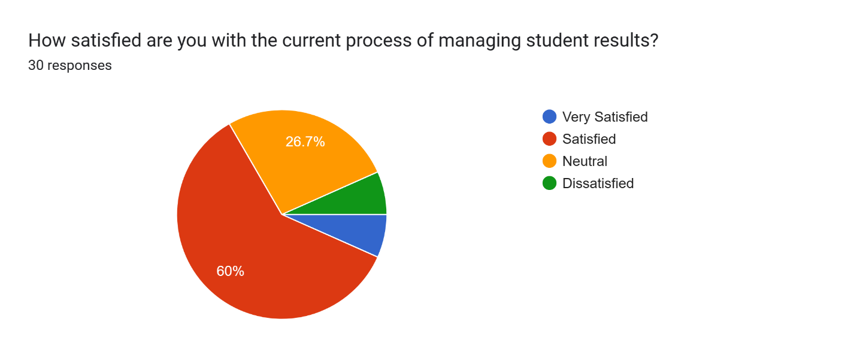

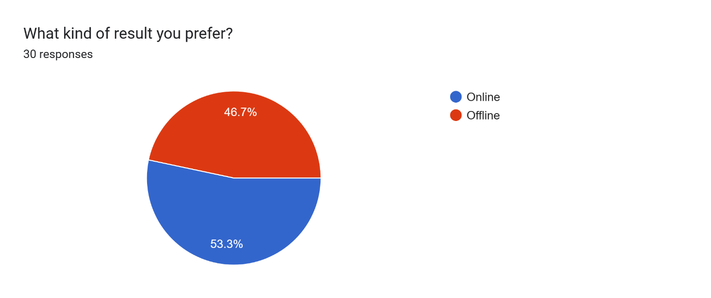

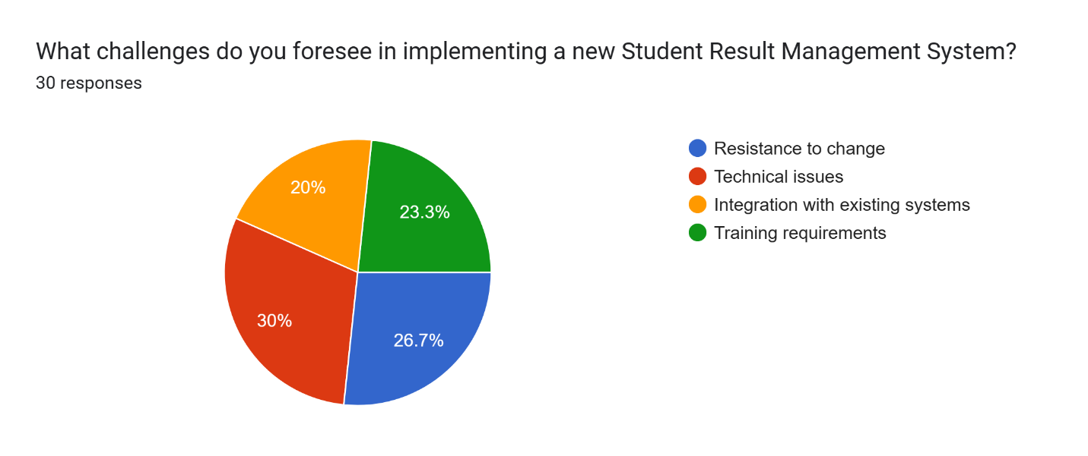

## **Expert Advice**

* Understand Stakeholder Requirements: Prioritize understanding the specific needs and requirements of stakeholders, including teachers, administrators, students, and parents. Conduct thorough interviews and workshops to gather insights and align the system's functionalities with their expectations.
* Modular Design and Scalability: Design the system in a modular fashion, allowing for scalability and future enhancements. Break down the system into manageable modules with well-defined interfaces, making it easier to extend and adapt as needs evolve.
* Usability and User Experience (UX): Focus on creating an intuitive and user-friendly interface to enhance the overall user experience. Conduct usability testing to identify any pain points and iteratively improve the design based on feedback.
* Data Security and Privacy: Prioritize data security and privacy by implementing strong encryption mechanisms, access controls, and compliance with relevant data protection laws. Educate users and administrators about best practices for safeguarding sensitive student information.
* Reliable Data Backup and Recovery: Implement a robust data backup and recovery strategy to ensure that student data is securely stored and can be restored in case of accidental loss, hardware failure, or other emergencies.
* Compliance with Standards: Adhere to industry standards and best practices in software development, database management, and data handling. Compliance with standards ensures that the system is reliable, maintainable, and interoperable with other systems.
* Performance Optimization: Optimize the system's performance to ensure that it can handle a large volume of data and user interactions efficiently. Regularly monitor and fine-tune the system for optimal response times and resource utilization.
* Documentation and Training: Maintain comprehensive documentation for the system, including technical specifications, user manuals, and system architecture. Conduct training sessions for users and administrators to ensure they can effectively use and manage the SRMS.
* Iterative Development and Feedback Loop: Adopt an agile development approach with frequent iterations and feedback loops. Engage stakeholders at various stages of development to gather feedback and make necessary adjustments to align the system with their expectations.
* Collaboration and Communication: Foster open communication and collaboration among the development team and stakeholders. Regularly update stakeholders on the project's progress, challenges, and milestones, ensuring a shared understanding and alignment with project goals.

## **Current/Future requirements**

### **Current Requirements**

* User Authentication and Authorization: Implement secure and efficient user authentication mechanisms, including multi-factor authentication, to ensure that only authorized individuals can access and modify student data and results.
* Mobile Accessibility: Design the SRMS to be responsive and accessible on various mobile devices, allowing stakeholders to access important information on-the-go, enhancing usability and convenience.
* Integration with Existing Systems: Enable seamless integration with other educational systems, such as Learning Management Systems (LMS), to facilitate efficient data exchange and collaboration between platforms.
* Real-time Data Updates: Provide real-time updates for student results, attendance, and other important information, enabling immediate access to the latest academic data for teachers, students, and parents.
* Reporting and Analytics: Incorporate advanced reporting and analytics features to generate insightful reports, dashboards, and visualizations, allowing administrators and educators to analyze student performance trends and make data-driven decisions.

### **Future Requirements**

* Artificial Intelligence (AI) and Machine Learning (ML) Integration: Integrate AI and ML algorithms to predict student performance, identify patterns, and suggest personalized learning paths, enhancing the overall educational experience.
* Blockchain for Data Security: Explore the use of blockchain technology to enhance data security, transparency, and integrity, ensuring that student records and results are tamper-proof and immutable.
* Data Privacy Compliance: Stay updated with evolving data privacy laws and regulations, ensuring compliance with the latest standards to protect student data and privacy effectively.
* Virtual Reality (VR) for Enhanced Learning: Consider incorporating VR technology to provide interactive learning experiences, enabling students to engage with educational content in an immersive and engaging manner.
* Chatbots for Support and Assistance: Implement AI-powered chatbots to provide real-time support and assistance to students, parents, and teachers, offering instant responses to queries and concerns.
* Adaptive Learning Paths: Develop adaptive learning algorithms that tailor educational content and resources based on a student's learning style, pace, and preferences, promoting personalized and effective learning.
* Blockchain-based Certificates and Credentials: Utilize blockchain to issue and manage academic certificates and credentials securely, ensuring the authenticity and integrity of the certification process.

# **Overall Description**

## **Product Functions**

### **Hardware Requirement**

* **Processor**: Multi-core, modern processors (e.g., Intel Xeon, AMD EPYC) to handle concurrent requests efficiently. RAM: At least 16 GB to accommodate database operations, application caching, and concurrent user sessions.
* **Storage**: SSD (Solid State Drive) for improved data access speed and reliability.
* **Operating** **System**: Linux (e.g., Ubuntu Server, CentOS) or Windows Server.
* Database Server: Processor: Similar to the main server for efficient database processing.
* **RAM**: Adequate RAM to handle database operations and caching.
* **Storage**: SSD for faster data retrieval and transactions.
* **Database** **Management** **System**: Depending on requirements, MySQL, PostgreSQL, or other suitable databases.
* **Networking**: High-speed internet connection with sufficient bandwidth to handle user interactions and data transfers. Network devices like switches, routers, and firewalls to ensure secure and efficient communication within the system.
* **Load** **Balancer** (**for Scalability):** If expecting high traffic, consider implementing a load balancer to distribute incoming requests across multiple servers for better performance and reliability.
* **Backup** **System**: Regular automated backup solutions for data protection and recovery in case of failures.
* **Power Supply and Backup:** Uninterruptible Power Supply (UPS) to ensure continuous operation during power outages.
* **Client Devices (used by users to access the SRMS):** PCs, laptops, tablets, or smartphones with compatible web browsers and internet connectivity.
* **Security Infrastructure:** Firewalls, Intrusion Detection Systems (IDS), and other security measures to protect the system from potential threats and attacks.
* **Scalability Considerations:** Ensure that the hardware architecture allows for easy scaling to accommodate growth in users and data volume.

### **Software Requirement**

* **Operating Systems:** The SRMS should be compatible with popular operating systems such as Windows (latest versions), Linux (e.g., Ubuntu, CentOS), macOS (latest versions)
* **Programming Languages:** Select appropriate programming languages for different parts of the system. For backend we can use Python, Java, PHP, or any other suitable language for server-side logic. For frontend we can use HTML5, CSS, JavaScript, and frameworks like Angular, React, or Vue.js.
* **Development Frameworks:**Utilize relevant development frameworks to expedite development and enhance efficiency such as Django, Flask, or Express.js for backend development such as Angular, React, or Vue.js for frontend development.
* **Database Management System (DBMS):**Choose a reliable DBMS to store and manage student and academic data such as MySQL, PostgreSQL, MongoDB, or Oracle Database.
* **Web Server:** Use a web server to host the application and serve web pages such as Apache, Nginx, or Microsoft Internet Information Services (IIS).
* **Version Control:** Employ a version control system to manage source code and track changes such as Git (with platforms like GitHub, GitLab, or Bitbucket).
* **Integrated Development Environment (IDE):** Provide guidelines for using suitable IDEs to streamline development such as Visual Studio Code, PyCharm, IntelliJ IDEA, or Sublime Text.
* **Authentication and Authorization:** Implement secure authentication and authorization mechanisms to control access: OAuth, JWT (JSON Web Tokens), or similar technologies.
* **APIs:** Define APIs for communication between different system components and third-party integrations such as RESTful APIs using HTTP/HTTPS protocols.
* **Testing Frameworks:** Select testing frameworks for automated testing and quality assurance such as Selenium, Jest, JUnit, or PyTest for various testing needs (unit, integration, end-to-end).
* **Security Tools**: Utilize security tools to scan and secure the application against vulnerabilities such as OWASP ZAP, Nessus, or similar tools for security testing.
* **Documentation and Collaboration:** Use tools to document the code and facilitate collaboration among team members such as Confluence, Jira, GitLab Wiki, or similar collaboration platforms.
* **Deployment and Containerization:** Determine the deployment strategy and containerization tools such as Docker, Kubernetes, or other suitable tools for container orchestration and management.
* **Logging and Monitoring:** Implement logging and monitoring tools to track application performance and troubleshoot issues such as ELK Stack (Elasticsearch, Logstash, Kibana), Prometheus, Grafana.
* **Backup and Recovery:** Define processes and tools for data backup and recovery such as automated backup solutions and scheduled backup routines.

## **Functional Requirements**

### **User Login**

**Description** : User Authentication is a fundamental functional requirement within the Student Result Management System (SRMS) that governs the process of validating the identity and authorization of individuals attempting to access the system. It ensures that only authenticated and authorized users can interact with the SRMS, thereby safeguarding the security and confidentiality of student-related data and system functionality.

#### **Admin**

* **Input :**
* **Username**: Unique identifier provided by the user.
* **Password**: Secure, confidential passphrase chosen by the user. Additional Verification (e.g., Email, Phone Number): An additional piece of information for enhanced security, often used for account recovery or two-factor authentication.
* **Output :**
* **Successful Authentication**: If the provided username and password match the records in the system, the authentication is successful. The user is granted access to the system with appropriate permissions based on their role.
* **Failed Authentication:** If the provided credentials (username or password) do not match any records in the system, authentication fails. The system denies access and often provides an error message indicating invalid credentials.
* **Error :**
* **Invalid Credentials:** Error message indicating that the provided username or password is incorrect.
* **Account Not Found**: Error message indicating that the provided username does not exist in the system.

#### **Teacher**

* **Input :**
* **Username**: Unique identifier provided by the user.
* **Password**: Secure, confidential passphrase chosen by the user. Additional Verification (e.g., Email, Phone Number): An additional piece of information for enhanced security, often used for account recovery or two-factor authentication.
* **Output :**
* **Successful Authentication**: If the provided username and password match the records in the system, the authentication is successful. The user is granted access to the system with appropriate permissions based on their role.
* **Failed Authentication:** If the provided credentials (username or password) do not match any records in the system, authentication fails. The system denies access and often provides an error message indicating invalid credentials.
* **Error :**
* **Invalid Credentials:** Error message indicating that the provided username or password is incorrect.
* **Account Not Found**: Error message indicating that the provided username does not exist in the system.

#### **Student**

* **Input :**
* The student must provide their unique roll number and class name to access their results.
* **Output :**
* Upon successful login, the system displays the student's academic results, including grades, marks, and performance summary for their specified class.
* **Error :**
* If the provided roll number or class name is incorrect, the system should display an error message indicating that the login credentials are invalid and prompt the student to re-enter the correct information.

### **Add or Manage Students**

**Description** : Student Registration is a fundamental functional requirement within the Student Result Management System (SRMS) that governs the process of enabling students to create an account within the system. This feature facilitates the establishment of a unique digital identity for each student, ensuring their accurate representation and participation within the academic platform.

* **Input:**
* **Personal Information:** Name, date of birth, contact information, and address provided by the student during the registration process.
* **Enrollment Information:** Student ID, program, academic year, and any other enrollment-related details supplied by the student during registration.
* User Credentials: Username and password chosen by the student to set up their login credentials.
* **Output :**
* **Registration Success:** Confirmation message indicating successful registration and providing information about the next steps, such as email verification.
* **Email Verification Request:** Notification requesting the student to verify their email address by clicking a link sent to the provided email during registration.
* **Account Activation Prompt:** Notification indicating that the account needs to be activated by confirming the provided email address, enabling the student to access the system.
* **Error:**
* **Invalid Email Format:** The system detects an email format that does not comply with the standard email structure (e.g., missing "@" symbol).
* **Username Already Exists:** The chosen username is already taken by another user in the system, prompting the student to choose a different username.
* **Incomplete Information:** The student attempts to proceed with the registration without providing all the required information, and the system prompts them to fill in all mandatory fields.

### **Course Management**

**Description :** Course Management within the Student Result Management System involves the ability to create, organize, and administer academic courses. This functional requirement encompasses functionalities such as course creation, modification, enrollment management, and grading. It ensures seamless organization of courses, accurate enrollment of students, and efficient tracking of student progress and performance through grading mechanisms. Additionally, course management allows for the association of instructors with courses, providing a comprehensive system for managing the academic curriculum and ensuring a structured and effective educational experience for both students and educators.

* **Input**
* **Course Details:** Course name, code, description, credits, instructor, and other relevant details provided during the creation of a new course.
* **Enrollment Information:** Student ID or username for enrolling students in a particular course.
* **Grading Information:** Assignment scores, exam scores, and other grading parameters used to evaluate student performance in a course.
* **Output**
* **Course Creation Success:** Confirmation message indicating successful creation of a new course, along with the course details and enrollment options.
* **Enrollment Success:** Confirmation message indicating successful enrollment of a student in a course, along with course details and access instructions.
* **Grading Update Confirmation:** Notification confirming successful update of student grades for a particular course, providing a summary of the updated grades.
* **Error**
* **Course Code Duplication:** The system detects an attempt to create a course with a course code that already exists, and prompts for a unique course code.
* **Student Already Enrolled:** When attempting to enroll a student who is already enrolled in the course, the system prompts that the student is already a member of the course.
* **Invalid Grading Input:** The system identifies an attempt to input grades that do not fall within the acceptable grading scale (e.g., a grade higher than 100%), and prompts for valid grading inputs.

### **Grade Entry**

**Description** : Grade Entry is a pivotal functional requirement that involves the systematic recording and input of student performance data into the Student Result Management System. This process includes capturing various assessment results, assignments, exams, and other academic evaluations. The accurate and timely entry of grades is essential for maintaining precise academic records, facilitating result generation, and providing a comprehensive overview of student progress within the educational platform

* **Input**
* **Student Information:** Student ID or username, identifying the student associated with the grades being entered.
* **Course Details:** Course name or course code, specifying the course for which grades are being recorded.
* **Assessment Scores:** Scores or grades for various assessments (e.g., exams, assignments) associated with the specified course and student.
* **Output**
* **Grade Entry Confirmation:** Confirmation message indicating successful entry of grades for the specified student and course.
* **Grade Summary:** A summary of the entered grades for the student in the specified course.
* **Grade Entry Log:** A log or record detailing the grades that have been successfully entered into the system, providing an audit trail.
* **Error**
* **Invalid Student ID:** The system detects an attempt to enter grades for a nonexistent or invalid student ID, prompting the user to provide a valid student ID.
* **Course Not Found:** The specified course name or code does not match any existing courses, resulting in a notification that the course is not found.
* **Incorrect Grade Format**: The system identifies an attempt to enter a grade in an incorrect format (e.g., non-numeric characters for a numeric grade), prompting the user to provide a valid grade format.

### **Result Generation**

**Description** : Result Generation is a critical functional requirement focused on automating the computation of final grades based on the collected student performance data. This process entails applying predetermined grading algorithms or criteria to the recorded scores, resulting in the generation of comprehensive academic results. Efficient result generation not only saves time but also ensures consistency and fairness in evaluating student achievements, ultimately providing a reliable basis for academic assessment.

* **Input**
* **Graded Assessments**: Grades obtained by the student in various assessments (e.g., exams, assignments) for a specific course.
* **Grading Criteria:** Predefined grading criteria or algorithms used to calculate the final result based on the assessed grades.
* **Student Information:** Student ID or username, identifying the student for whom the results need to be generated.
* **Output**
* **Generated Result:** Final academic result (e.g., grade, GPA) for the student in the specified course based on the provided assessment grades and grading criteria.
* **Result Summary:** A summary of the calculated result, showcasing individual assessment scores and the overall result.
* **Result Report:** A detailed report presenting the student's result, including performance analytics and comparisons (if applicable), providing a comprehensive overview of academic performance.
* **Error**
* **Invalid Grading Criteria**: The system detects an attempt to use invalid or undefined grading criteria for result generation, prompting the user to select appropriate and predefined grading criteria.
* **Incomplete Assessment Scores**: The system identifies missing or incomplete assessment scores for the specified student, indicating that all assessment scores must be provided for accurate result generation.
* **Unavailable Student Information:** The system is unable to retrieve student information based on the provided student ID or username, indicating a problem with data retrieval or input. The user is prompted to recheck the input or try again later.

### **Grade Modification**

**Description** : Grade Modification is a functional requirement that grants authorized users the capability to adjust or modify student grades when necessary. This feature is crucial for rectifying input errors, addressing exceptional circumstances, or accommodating reevaluation requests. By allowing authorized individuals to make grade adjustments, the system ensures accuracy and fairness, enhancing the credibility and reliability of the student evaluation process.

* **Input**
* **Student Information:** Student ID or username, identifying the student whose grades need to be modified.
* **Course Details**: Course name or course code, specifying the course for which grades are to be modified.
* **Modified Grades**: Updated scores or grades for various assessments (e.g., exams, assignments) associated with the specified course and student.
* **Output**
* **Modification Confirmation:** Confirmation message indicating successful modification of grades for the specified student and course.
* **Updated Grade Summary**: A summary of the modified grades for the student in the specified course, reflecting the changes made.
* **Grade Modification Log**: A log or record detailing the modifications made to the grades, providing an audit trail for accountability.
* **Error**
* **Unauthorized Access:** The system identifies an attempt to modify grades by an unauthorized user, prompting an access denied error and notifying the user that only authorized personnel can perform grade modifications.
* **Incorrect Grade Format:** The system detects an attempt to modify a grade using an incorrect format (e.g., non-numeric characters for a numeric grade), prompting the user to provide a valid grade format.
* **Course Not Found:** The specified course name or code does not match any existing courses, resulting in a notification that the course is not found and grade modification cannot proceed for an invalid course**.**

### **Data Visualization**

**Description** : Data Visualization is an important functional requirement that focuses on presenting student performance data in a visually appealing and informative manner. This functionality transforms raw academic data into insightful graphs, charts, or other visual representations, aiding educators and administrators in comprehending trends, patterns, and areas for improvement. Effective data visualization facilitates informed decision-making, enabling stakeholders to tailor educational strategies and interventions to optimize student outcomes.

* **Input**
* **Student Performance Data:** Student assessment data, including exam scores, assignment grades, and other academic performance metrics.
* **Visualization Type Selection:** User's choice of visualization type (e.g., bar chart, line graph, pie chart) to represent the data.
* **Time Frame Selection:** User's selection of the time frame for data visualization (e.g., monthly, quarterly, semester-wise).
* **Output**
* **Visualization Display**: The selected student performance data displayed in the chosen visualization type (e.g., a bar chart showing exam scores).
* **Visual Representation Summary:** A summary of the visual representation, explaining the patterns and trends observed in the data visualization.
* **Downloadable Visualization:** Option to download the visualization in a downloadable format (e.g., PDF, image file) for offline use or sharing.
* **Error**
* **Invalid Data Format:** The system detects an attempt to visualize data in an unsupported or incorrect format, prompting the user to upload data in the appropriate format.
* **Unsupported Visualization Type**: The selected visualization type is not supported or unavailable for the given data, prompting the user to choose a different visualization type.
* **Data Not Available:** The system is unable to retrieve the requested data for visualization, indicating a problem with data availability or retrieval. The user is prompted to try again later or contact support.

## **Non-Functional Requirements**

### **Correctness Requirement**

* **Algorithmic Precision:** The system must execute algorithms and calculations with precision to ensure accurate grading and assessment results.
* **Adherence to Academic Standards**: The system must adhere to established academic grading standards and policies to generate results consistently and correctly.
* **Error-Free Data Handling**: The system must handle and process data accurately, preventing errors in data input, computation, and storage to maintain data integrity and correctness.

### **Portability requirement**

* **Cross-Platform Compatibility:** The software must be compatible with various platforms (e.g., Windows, macOS, Linux) to ensure users can access and use the application seamlessly across different operating systems.
* **Ease of Deployment:** The system should be easy to deploy, allowing for straightforward installation and configuration on different hardware and software environments.
* **Data Transferability:** The software must facilitate easy transfer of data between instances or installations, ensuring data portability and accessibility when migrating to different systems or versions.

### **Efficiency Requirement**

* **Response Time Optimization:** The system must respond to user interactions promptly, ensuring low latency and efficient performance to enhance user experience.
* **Resource Utilization Efficiency**: The software should utilize system resources (CPU, memory, storage) efficiently, aiming for optimal usage to minimize resource wastage and maintain high performance.
* **Scalability and Performance Scaling**: The system must scale efficiently to handle an increasing number of users or growing data volumes, maintaining consistent performance levels and responsiveness even under increased load.

### **Usability Requirement**

* **Intuitive User Interface:** The system must feature an intuitive and user-friendly interface, allowing users to easily navigate and interact with the application without extensive training.
* **Accessibility and Inclusivity**: The software should adhere to accessibility standards, ensuring that individuals with disabilities can access and use the application effectively, promoting inclusivity and usability for all users.
* **Help and Documentation:** The system should provide comprehensive and easily accessible help resources, user guides, and documentation to assist users in understanding and utilizing the software's functionalities efficiently.

### **Reusability Requirement**

* **Modularity and Component Reusability**: The system should be designed with clear, modular components, allowing for easy identification and reuse of specific functionalities across the application or in other projects.
* **Code Reusability:** The software codebase should be well-organized and documented to encourage reuse of code snippets, functions, or modules in other parts of the system or in future projects, enhancing efficiency and maintainability.
* **Flexibility for Integration**: The system architecture should support seamless integration with other systems or software, enabling reusability of components or services in different contexts or environments, promoting interoperability and extensibility.

### **Reliability Requirement**

* **Fault Tolerance:** The system must maintain its functionality and availability even in the presence of faults or errors, ensuring uninterrupted performance and minimizing downtime.
* **Error Handling and Logging:** The software should effectively handle errors, log relevant information, and notify appropriate parties, enabling prompt identification and resolution of issues to maintain system reliability.
* **Data Integrity and Consistency:** The system must ensure the integrity and consistency of data throughout its lifecycle, preventing data corruption or loss to maintain the reliability and accuracy of information.

### **Maintainability Requirement**

* **Modifiability and Flexibility:** The system should be designed with modifiability in mind, allowing for easy updates, enhancements, or alterations to accommodate changing requirements and technological advancements while maintaining system stability.
* **Readability and Documentation:** The software codebase and design should be well-documented and written in a clear, understandable manner, aiding developers and maintainers in comprehending the system's architecture, logic, and functionalities for efficient maintenance and updates.
* **Standardized Coding Practices:** The system development should adhere to established coding conventions, guidelines, and best practices, ensuring a consistent and uniform codebase that is easier to maintain, debug, and enhance over time.

## **User Characteristics**

* **Students**: Students constitute a significant user group for the Student Result Management System. This group encompasses a diverse range of individuals, each with varying levels of technical proficiency. Some students may be highly adept with technology, while others may possess more limited tech skills. Their primary objective is to access and track their academic progress, view course information, and assess their performance over time. Providing an intuitive and user-friendly interface is essential to ensure students can easily navigate the system and retrieve the information they need promptly.
* **Teachers**/**Instructors**: Teachers and instructors play a crucial role in the system, actively engaging with the platform to input grades, assess student performance, and manage course-related data. Their level of technical proficiency typically ranges from moderate to advanced, depending on the educational institution and personal familiarity with digital tools. The system should prioritize ease of grade input, intuitive performance analysis tools, and quick access to relevant course-related information. Enhancing efficiency and minimizing the time spent on administrative tasks allows instructors to focus more on providing quality education to their students.
* **Administrators**: Administrators hold a vital position in managing and maintaining the Student Result Management System. This group possesses a moderate to advanced level of technical proficiency, coupled with a deep understanding of the administrative aspects of the educational institution. Their role involves configuring the system, managing user access, ensuring security, and customizing the system to suit the institution's needs. An efficient user management interface, robust security features, and a system that aligns with privacy regulations are key expectations to facilitate smooth administrative operations and secure handling of academic data.

## **Design & Implementation Constraints**

* **Design and Implementation Constraints**: The project needs to consider certain design and implementation constraints, such as adhering to the educational institution's existing infrastructure and technologies. Compatibility with prevalent browsers and devices is essential to ensure seamless access for a diverse user base. Additionally, the system design should accommodate scalability requirements to handle a potentially increasing volume of users and data.
* **Data Privacy and Compliance:** Design and implementation must adhere to data privacy laws and institutional policies. Data encryption, secure authentication mechanisms, and strict access controls are imperative to safeguard sensitive student information. Compliance with regulations like GDPR or FERPA is essential to ensure legal and ethical handling of academic data.
* **Integration with Existing Systems**: The system must integrate smoothly with existing educational tools and databases to ensure a cohesive ecosystem. API compatibility and data exchange standards need to be considered to facilitate interoperability with other educational applications. The design should enable efficient data synchronization and updates between the Student Result Management System and other institutional systems.

## **Assumptions & Dependencies**

* **Assumptions**: Certain assumptions guide the project, such as an assumption of consistent internet connectivity for users to access the system. It's also assumed that users have access to compatible devices (e.g., computers, tablets, smartphones) and standard web browsers. Additionally, the availability of essential student and course data for initial system setup and testing is assumed.
* **Dependencies**: The project relies on various dependencies, including external APIs or services for features like email notifications and authentication. Additionally, the project is dependent on the availability of a reliable hosting or cloud infrastructure to ensure system accessibility. Integration with existing databases and student information systems is a critical dependency for seamless data flow and accuracy within the Student Result Management System.

# **Interface Requirements**

## **User Interfaces**

The Student Result Management System will feature intuitive and user-friendly interfaces designed to cater to a diverse user base, including students, teachers, administrators, and parents. The interfaces will prioritize ease of navigation, clear display of academic data, interactive visualization of results, and a consistent layout to enhance usability. Tailored interfaces will meet the unique needs of each user group, providing an efficient and engaging user experience, ultimately promoting effective interaction with the system's functionalities.

## **Hardware Interfaces**

The Student Result Management System will be accessible through standard computing hardware, including desktops, laptops, tablets, and smartphones. The interfaces will be designed to ensure compatibility with various screen sizes and resolutions, enabling a seamless user experience across different devices. Users will interact with the system using input devices such as keyboards, mice, touchscreens, and stylus pens. The system will also rely on network connectivity for data access, leveraging internet capabilities for optimal performance and accessibility.

## **Software Interfaces**

The Student Result Management System will be designed to operate on standard web browsers, making it accessible across a range of operating systems, including Windows, macOS, and Linux. Users will require internet connectivity to access the system. Additionally, the software may rely on specific software components such as web servers, databases, and encryption protocols to ensure secure data storage and transmission. The system will be built using technologies that promote scalability, reliability, and cross-platform compatibility, facilitating efficient performance and accessibility for all users.

## **Communication Interfaces**

The Student Result Management System will utilize standard communication protocols over the internet to ensure seamless data exchange between users and the system. The system will employ HTTP/HTTPS for secure data transmission, enabling users to interact with the application via their preferred web browsers. Email notifications will be a key communication interface for system alerts, updates, and notifications, enhancing user engagement and providing timely information. API endpoints may be utilized to enable integration with external systems or services, facilitating efficient data exchange and interoperability.

# **Conclusion**

The Student Result Management System (SRMS) is a vital tool that aims to streamline and enhance the management of academic data within an educational institution. Throughout this Software Requirements Specification (SRS), we have meticulously defined the functional, non-functional, and user requirements essential for the successful development and implementation of the SRMS. The functional requirements have outlined the key features and actions the system must support, including grade entry, result generation, grade modification, data visualization, backup and recovery, and user authentication. These functions are central to the efficient and accurate management of student academic data. Additionally, the non-functional requirements, such as usability, performance, security, and reliability, are crucial aspects that ensure the system meets high standards of performance, user satisfaction, and data integrity. Understanding the diverse user base of the SRMS is fundamental to its success. Students, teachers, administrators, and parents all have unique needs and expectations from the system. The usability requirements emphasize the importance of an intuitive user interface that caters to varying levels of technical proficiency, enhancing accessibility and user engagement. Assumptions and dependencies have been carefully considered to guide the development process. Assumptions regarding consistent internet connectivity, availability of compatible devices, and accessible initial data are pivotal in outlining project expectations. Dependencies on external APIs, hosting infrastructure, and database integration underscore the collaborative nature of the project and its reliance on various components. In terms of interfaces, the system will be accessible through standard hardware and software, ensuring compatibility and ease of access for a diverse user base. Communication interfaces will utilize established protocols to facilitate secure and efficient data exchange, emphasizing the importance of seamless interactions between users and the system. In conclusion, this Software Requirements Specification forms the foundational blueprint for the development and implementation of the Student Result Management System. It sets the stage for efficient collaboration, guiding the development team in meeting the project objectives and exceeding the expectations of the educational institution and its stakeholders. The well-defined requirements and considerations encapsulated within this document provide a solid framework, ensuring the successful delivery of a robust, reliable, and user-centric Student Result Management System.